

Job Description:
Multi skilled M&E Shift Engineer

Function: |  |  | Energy & Resources - Technical Services
Job:
Position: |  |  | Multi Skilled M&E Shift Engineer
Job holder:
Date (in job since):
Immediate manager  (N+1 Job title and name): |  |  | Multi Skilled M&E Shift Lead Engineer
Additional reporting line to: |  |  | Engineering Support Manager
Position location: |  |  | Shell London
1. Purpose of the Job – State concisely the aim of the job.
- To assist the M&E Shift Leader/Senior supervisor and higher management in delivering a customer focused cost effective and efficient Hard Services delivery
- Deliver Multi Skilled engineering, Planned Maintenance, Reactive Maintenance and other engineering support as required in order to meet contractual and legal obligations.
- A minimum of 5 years’ experience in a mechanical / electrical multi skilled engineer role within a large commercial complex
- Provide fault diagnosis, repair & testing of all Electrical /Mechanical and Public health services, plant and equipment
- Ensure Health and Safety standards are maintained or exceed on every task
- Cover Callout duties as per the site rota and LOP
- Act as an Appointed Person or Competent Person in respective discipline as required
2. Dimensions – Point out the main figures / indicators to give some insight on the “volumes” managed by the position and/or the activity of the Department.
 |  | EBIT growth: | Tbc |  |  | Outsourcing rate: | n/a | Region Workforce | tbc
Revenue FY13: | €tbc | EBIT margin: | Tbc | Growth type: | n/a
Revenue FY13: | €tbc | Net income growth | : Tbc | Growth type: | n/a | Outsourcing growth rate: | n/a | HR in Region | tbc
 |  | Cash conversion: | Tbc
Characteristics |  | - Add point

3. Organisation chart – Indicate schematically the position of the job within the organisation. It is sufficient to indicate one hierarchical level above (including possible functional boss) and, if applicable, one below the position. In the horizontal direction, the other jobs reporting to the same superior should be indicated.
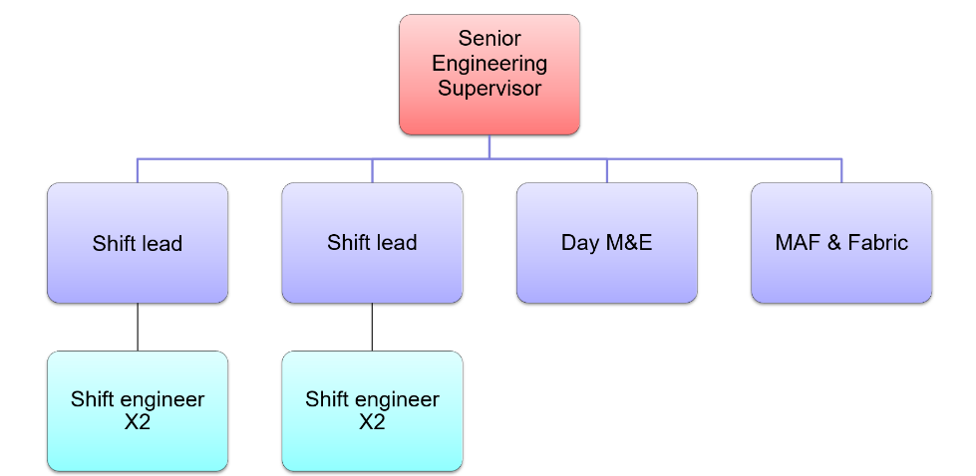

Engineering Manager

4. Context and main issues – Describe the most difficult types of problems the jobholder has to face (internal or external to Sodexo) and/or the regulations, guidelines, practices that are to be adhered to.
Technical
- Be fully competent in the fault diagnosis, repair testing and maintenance of Electrical, Mechanical and Public Health assets, plant, and equipment
- Support the business in production/recording of statutory documentation ensuring a compliant and auditable database
- Ensure HSE, statutory and mandatory tasks are completed correctly and on time.
- Support stock purchasing and goods receipting processes.
- Support the works control of contractors process through contractor inductions, hosting and safety walks, completing all paperwork as required.
- Attend and contribute to Toolbox talks and GREAT Training sessions and record attendance as required
- Ensure any work completed is supported by a fit for purpose set of RAMS
- Report all accidents and near misses as soon as possible to your Shift lead and/or Engineering manager and in accordance with process.
- Ensure all plant room and storage facilities are both clean and tidy with regular weekly inspections carried out and documented.
- To make sure any plant withdrawn from service is isolated, locked and tagged correctly and tracked until back in service using both email correspondence and the Shift logbook.
- Assist the Engineering management team/Command Centre by advising Shift lead of any PM’s that are outstanding and will affect the performance of the Building or Client reports, to ensure zero failure.
- Prioritise PMs to ensure all works are completed on schedule and relevant electronic documentation is completed via PDA to a constant high standard incorporating all KPI elements – Labour, RAMS, Log notes etc
- Review PPM remedial/ follow on works or defect works and ensure all PPM are raised for defects/remedials works.
- Ensure 0% failure on Statutory/Mandatory PM tasks and no more than 5% failure on routine /reactive breaches by clearing tasks from Maximo PDA in accordance with SLA
- Support Shift Lead / Senior Supervisor and higher management in highlighting any works which are unable to be completed in line with SLA due to unforeseen /acceptable reasons in order to mitigate any risk to business and to enable deferral notice to be raised.

General
- Comply with all contractual SLA’s and KPI’s
- Deputise for the Shift leader in times of absence upon request
- Work with Command Centre to support delivery of a compliant HFM service
- To work with other members of the wider Real Estate Facilities Management Team, to provide great customer service.
- Ensure that you present a smart appearance and professional attitude whilst representing Sodexo/Real Estate Facilities Management
- Be responsive to the need to work extended hours & also weekends when requested.
- Comply with absence and attendance management policy & procedures and ensuring Kronos time management system is used to clock in/out book leave etc
- Support the shift lead in completion of the shift log by proactively providing relevant and priority information to inform and assist all and to help understand ongoing issues therefore mitigating/reducing risk to the business.
- Attend appropriate training courses to cover technical and customer service as and when required.
- Support Client/Sodexo project related activity by facilitating enabling works – eg isolations,permits etc
- There may be a requirement to support and work at Shell satellite sites as required by the needs of the business

5. Main assignments – Indicate the main activities / duties to be conducted in the job.
- Responsible for the completion of standard or non-standard tasks, within the scope of the function
- Delivers activities to support operational objectives for their role
- Makes decisions within parameters set by manager, using job/specialist experience
- Interacts with client or users around specific work efforts and deliverables
- Supports delivery of Health and Safety policy and standards
- Supervises the activities of others to meet deadlines and quality standards taking account of impact outside area of responsibility
- Focus of work on the completion of a set of related tasks for a particular section or service with the ability to accommodate new tasks
- There is a requirement to support unsocial working hours / Out of hours works

6. Accountabilities – Give the 3 to 5 key outputs of the position vis-à-vis the organization; they should focus on end results, not duties or activities.
- Lead by example in Health and Safety, Customer Service and Operational delivery
- Actively manage work load and escalate at the earliest opportunity in the delivery of a fully compliant asset base
- Support the wider site team in delivering the client and business goals
- Assist less experienced staff where possible

7. Person Specification – Indicate the skills, knowledge and experience that the job holder should require to conduct the role effectively
- Essential - served a recognised apprenticeship in relevant discipline with City & Guilds Craft Certificate/ ONC in relevant engineering discipline or equivalent
- Desirable - minimum 5 years’ experience in an M&E role in a large, complex commercial environment
- Previous experience in Building Services / FM Engineering environment
- Previous experience of working as a Competent person within relevant discipline.
- Desirable - Previous experience of working as an Authorised Person
- Experience of Electrical, Mechanical, Heating, Cooling, Ventilation, Water systems, Public health systems etc
- Effective communicator, both verbally and written
- Strong health and safety culture
- Full driving license held for a minimum 2 years

8. Competencies – Indicate which of the Sodexo core competencies and any professional competencies that the role requires
 | Growth, Client & Customer Satisfaction / Quality of Services provided | Leadership & People Management
 | Rigorous management of results | Innovation and Change
 | Employee Engagement

9. Management Approval – To be completed by document owner
 | Version | V1.0 | Date | December 2021
 | Document Owner | Brett O’Neill

