Job Description

Function: |  |  |  | Operations
Position: |  |  |  | Restaurant Manager – Tatha Bar and Kitchen
Job Holder:
Start Date:
Immediate Manager: |  |  |  | Fiona Pugh
Additional Reporting Line: |  |  |  | Yvonne Stirling
Position Location: |  |  |  | V&A Dundee, 1 Riverside Esplanade, Dundee, DD1 4EZ
- Purpose of the job

1 | To be the lead manager for Tatha Bar and Kitchen operation, support the pop up food and beverage pop up outlets and events and to consistently exceeding the expectations of all customers and visitors.
2 | Set and maintain an exceptionally high standard of food service in Tatha Bar and Kitchen.
3 | To provide open and effective communication to all HPL Managers and clients
4 | To provide support to aid management cover when required within the V&A and other HPL properties.
5 | Create and maintain a safe working environment which meets all current legislative and Covid secure responsibilities.
6 | Ensure effective and acceptable lines of communication between Tatha Bar and kitchen clients and senior management.
5 | To ensure the management of the highest standards of cleanliness, tidiness and maintenance in Tatha Bar and Kitchen at all times.
6 | Create and maintain a safe, happy and committed working environment for the Tatha team, with an emphasis on development for all staff.
7 | Assist and support the General Manager and Lead Chef on key financial aspects within the P&L to achieve budget, and look to improve budget where possible.
8 | Provide innovation and new product ideas, and where practicable, use and promote local ingredients and suppliers.
- Commercial remit
Revenue: FY | £ tbc | EBIT growth | tbc |  | Growth Type |  | Outsourcing Rate |  |  |  | Region Workforce
Revenue: FY | £ tbc | EBIT margin | tbc
Revenue: FY | £ tbc | Net income growth | tbc |  | Growth Type |  | Outsourcing Growth Rate |  |  |  | Outsourcing Growth Rate
Revenue: FY | £ tbc | Cash Conversion | tbc
Characteristics |  | Financial

3. Organisation Chart

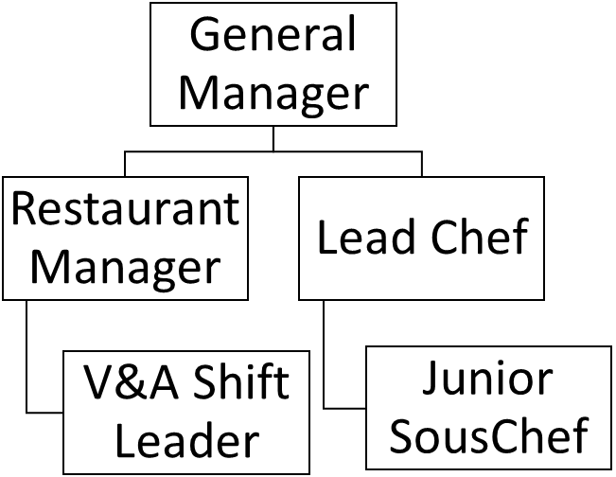

- Context and main issues

1 | Ensure Tatha Bar and Kitchen delivers a high quality food and service at all times
2 | Work with the General manager on financial targets and planning for Tatha Bar and Kitchen
3 | Ensure that all Health & Safety legislation is carried out correctly and recorded as necessary. This includes all HACCP and COSHH responsibilities, as well as EHO visits, Fire Evacuation Procedure, First Aid at Work and safe working practices.
4 | Maintain a focus on food allergens and customer information including following and training staff on new procedures, recording and management
4 | Ensure the team are trained on all necessary legislative and Covid secure aspects of the restaurant

- Main assignments

1 | Ensure that members of the team are fully aware of and given support to achieve set objectives
2 | Ensure a focus on customer needs and feedback, and ensure that any food queries or complaints are dealt with promptly and professionally
3 | Ensure all equipment under your supervision is maintained in working order and kept clean, has clear operations instructions, is safe and secure with any issues being reported at the first available opportunity, and that all staff are regularly retrained on use of equipment
4 | Keep records of any equipment maintenance required, and update the asset register as necessary
5 | Maintain , update and ensure all Covid secure practises are consistently followed

- Accountabilities

 | 1 | Ensure that all members of the team are fully aware of and achieve any set objectives
 | 2 | Ensure a focus on customers’ needs and feedback, and ensure that any food queries or complaints are dealt with promptly and professionally
 | 3 | Ensure all equipment under your supervision is maintained in working order and kept clean, has clear operations instructions, is safe and secure with any issues being reported at the first available opportunity, and that all staff are regularly retrained on use of equipment
 | 4 | Ensure that all Health & Safety legislation is carried out correctly and recorded as necessary. This includes all HACCP and COSHH responsibilities, as well as EHO visits, Fire Evacuation Procedure, First Aid at Work and safe working practices at all times. Maintain a focus on food allergens and customer information.
 | 5 | Maintain a focus on food allergens updates and staff training.
- Person Specification

1 |  |  | Natural creative and innovative flair with a genuine love of food and an eye for detail
2 |  |  | Excellent people management skills, with a desire to share knowledge and best practises
3 |  |  | Knowledge of Excel, Word and Microsoft Outlook
4 |  |  | Industry awareness from high street to high end cafes.
5 |  |  | Ability to multi-task
6 |  |  | Professional, motivated, driven, flexible and enthusiastic
7 |  |  | Ability to innovate solutions and prioritise workload

- Competencies

. | Commercial awareness | . | Computer literate
. | Growth, client & customer satisfaction / quality of services provided | . | Leadership & People Management

