
Job Description: Supervisor
The King’s School, Chester

Function: | Operations
Job: | Supervisor
Position:
Job holder: | Vacant
Date (in job since):
Immediate manager  (N+1 Job title and name): | General Catering Manager
Additional reporting line to: | Head Chef
Position location: | The King’s School, Chester
1. Purpose of the Job – State concisely the aim of the job.
- Deliver a warm, welcoming, and high-quality hospitality experience for everyone at the School, including pupils, staff, visitors, and external guests.
- Provide friendly, efficient service that makes every customer feel valued, always aiming to exceed expectations.
- Lead by example with a positive, customer-focused attitude and consistently high standards of service.
- Support and encourage the team by monitoring day-to-day performance, identifying training needs, and helping colleagues develop their skills.
- Help deliver a wide range of hospitality services, including fine dining, casual dining, and conferences ensuring everything runs smoothly for both the School and external guests.
Draft. Version: 27-03-2014
2. Organisation chart – Indicate schematically the position of the job within the organisation. It is sufficient to indicate one hierarchical level above (including possible functional boss) and, if applicable, one below the position. In the horizontal direction, the other jobs reporting to the same superior should be indicated.
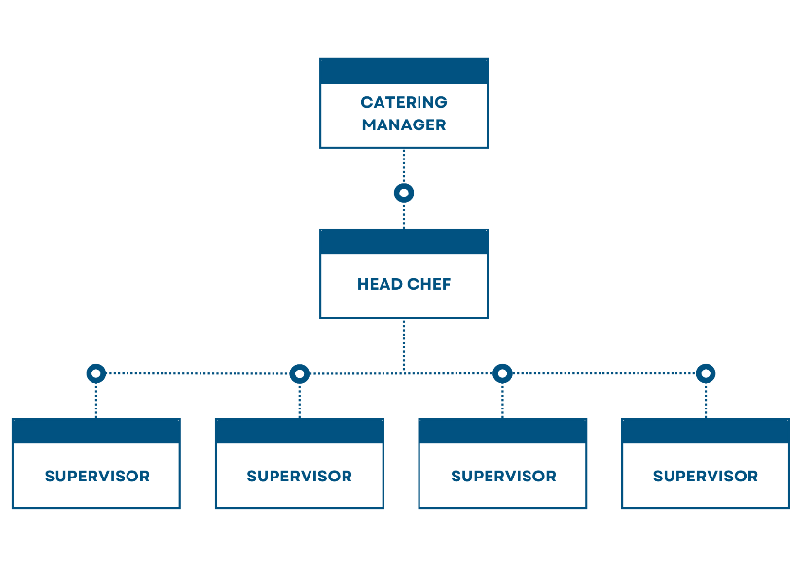

4. Context and main issues – Describe the most difficult types of problems the jobholder has to face (internal or external to Sodexo) and/or the regulations, guidelines, practices that are to be adhered to.
- Deliver a high-quality food and beverage service across the School, helping create a welcoming and enjoyable experience for pupils, staff, and visitors.
- Bring enthusiasm, fresh ideas, and creativity to the role, helping keep the catering offer exciting and supporting the school's vision of bringing joy to student life through food.
- Be confident working in a busy, fast-paced environment, supporting high-volume student dining, retail outlets, and a varied programme of events throughout the year.

5. Main assignments – Indicate the main activities / duties to be conducted in the job.
Hospitality Operations
- Work closely with the Catering Manager to understand the day's priorities and support the smooth running of the operation.
- Communicate effectively with the Head Chef and kitchen team to ensure events and functions are delivered successfully.
- Support and motivate the catering team to provide excellent customer service at every event.
- Lead by example, promoting high standards of service and reflecting the values of both the School and Sodexo in everything you do.
- Help ensure all food safety, hygiene, and health & safety procedures are followed, maintaining compliance with School and Sodexo standards.

6. Accountabilities
- To deliver a consistent level of service, within the Company's high standards, to the contract specification and agreed performance, qualitative and financial targets.
- Comply with Company and statutory regulations relating to safe systems of work, Allergens, health & safety, hygiene, cleanliness, fire and COSHH.

7. Person Specification – Indicate the skills, knowledge and experience that the job holder should require to conduct the role effectively

Essential

- Previous experience in a hospitality, catering, or events environment.
- A passion for delivering excellent customer service and creating a welcoming experience for pupils, staff, visitors, and guests.
- Good communication and interpersonal skills, with the ability to build positive relationships with colleagues and customers.
- Ability to lead by example, motivate a team, and support colleagues during busy service periods.
- Organised and able to prioritise tasks while working in a fast-paced environment.
- Flexible approach to work, with the ability to adapt to changing priorities and support a variety of hospitality events.
- Good understanding of food hygiene, health and safety, and allergen awareness.
- Willingness to work evenings and weekends when required to support school events.

Desirable

- Previous experience within an education, independent school, or conference and events environment.
- Level 2 Food Safety Certificate (or willingness to achieve this).
- Knowledge of stock control, ordering, and cash handling procedures.
- Experience of training, coaching, or mentoring team members.

8. Competencies – Indicate which of the Sodexo core competencies and any professional competencies that the role requires
- Passionate about delivering excellent customer service and creating a welcoming experience for pupils, staff, visitors, and guests.
- Friendly, approachable, and enthusiastic, with a positive attitude that encourages others.
- Takes pride in maintaining high standards and is always looking for ways to improve the customer experience.
- Self-motivated and proactive, using initiative to solve problems and keep the operation running smoothly.
- A strong team player who builds positive working relationships with colleagues, customers, and stakeholders at all levels.
- Flexible and adaptable, remaining calm and organised in a busy, fast-paced environment.
- Leads by example, supporting and encouraging colleagues to achieve high standards.
- Reliable, responsible, and committed to completing tasks to a high standard and on time.
- Confident in making day-to-day decisions and resolving issues quickly and professionally.
- Open to feedback and committed to learning and developing both personally and as part of the team.
- Takes ownership of their work and understands the importance of following food safety, health & safety, and company procedures.
- Uses good judgement to assess situations, identify solutions, and make informed decisions when needed.

9. Management Approval – To be completed by document owner
Version | King’s, Chester 26 | Date | 29 June 2026
Document Owner | Jon Copeland

