
Job Description:
Electrical Maintenance Craftsperson - Estates

Function: | Hard FM Healthcare
Job: | Maintenance Craftsperson Electrical - Estates
Position: | Maintenance Craftsperson Electrical
Job Holder:
Date (in job since): | Not Applicable
Immediate Manager: | Electrical Technical Manager
Additional reporting line to: | Deputy Head of Estates
Position Location: | Hereford County Hospital

1. Purpose of the Job
- The post holder will be a key member of a skilled Estates Team. To provide a comprehensive and quality service in line with quality standards to the hospital, working with others as part of a developed team also responsible for contributing to the day-to-day maintenance.

- To achieve this the post holder will carry out a wide range of planned and reactive electrical / mechanical activities to a high standard.

- The post holder will carry out their duties in an efficient manner with full awareness, understanding and compliance with HTM’s and Good Industry Practice and the Trust and Sodexo’s Health and Safety, Infection Control Policies and Procedures including the Trust/Sodexo Permit to Work systems.

- At all times the post holder is to ensure timely action and a mobile telephone to enable communication with other departmental/non departmental staff of all positions as and when required. These communications will normally be via the Help Desk or in an emergency, direct from the Hospital switchboard the post holder will prioritize workloads at all times, work under pressure in emergency situations where failure to act promptly of safely may result in serious injury, damage or loss of life.

2. Dimensions
Revenue FY21: | tbc | EBIT growth: |  | tbc | Growth type: | NA | Outsourcing rate: | NA | Region Workforce | tbc
Revenue FY21: | tbc | EBIT margin: |  | tbc
Revenue FY21: | tbc | Net income growth: |  | tbc | Growth type: | NA | Outsourcing growth rate: | NA | HR in Region | tbc
Revenue FY21: | tbc | Cash conversion: |  | tbc
Characteristics’

Draft. Version: 27-03-2014
3. Organisation Chart
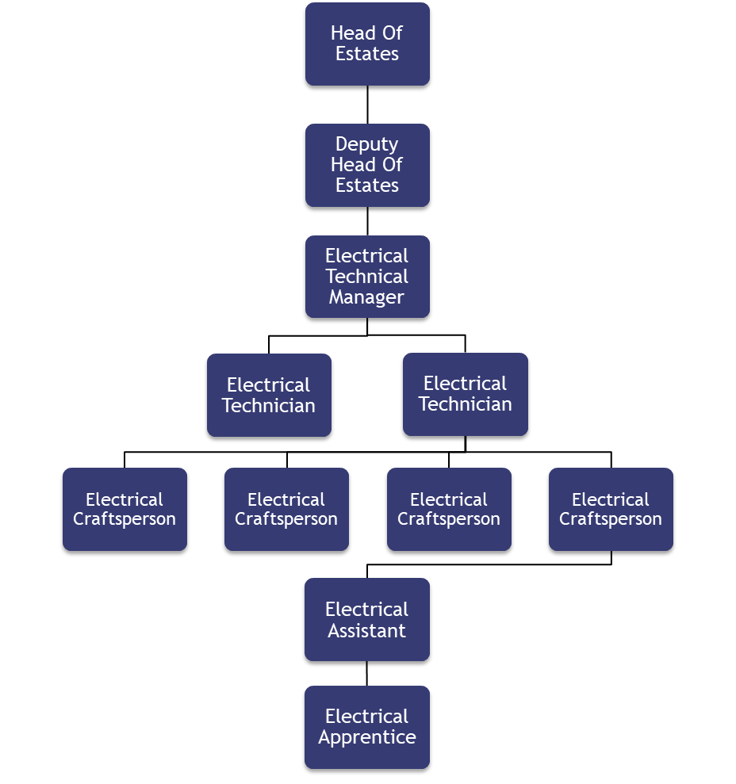

4. Main Assignments
- Exchange, interpret, analyse and calculate complex information and communicate to specialists and non-specialists
- Knowledge of the principles, concepts and standards associated with Building Energy Management Systems
- Have specialist skills and experience within the Healthcare maintenance environment
- Maintain and work with multiple BMS measurement tools and templates
- Collect all data and information necessary to analyse all aspects of the service in relation to estate management, taking into account legislation and future direction of legislation, health and safety, Trust and Sodexo policy. To use data and information in complex forms to benchmark, fault find, predict and analyse system failures
- Fully competent (AP/CP Appointed) in the fault diagnosis, maintenance, repair assets to include but not limited to Electrical systems such as LTHW Heating Systems, CHW Systems, Steam distribution systems, Hot Water Calorifiers, Refrigeration, Air Handling Units / Ventilation Systems, Compressed air and Medical Gas Systems
- Read electrical and panel draws to effect maintenance and repair of systems and equipment.
- Carry out Planned Maintenance of Electrical Devices in line with current regulations and manufacturers recommendations
- Comparison and utilisation of technical documents as issued by the Department of Health
- Interpretation of technical terminology used in the Electrical and Mechanical infrastructure
- The safe operation and maintenance of all plant and equipment within PFI Hospital site. Carrying out a range of repairs and new works to a high standard. Working on own initiative when applicable or as part of a team
- Supporting the Engineering Management team to ensure contractual response and rectification times are met. Producing required support documentation reports to meet contractual requirements.
- Undertaking Authorised Person and/or Competent Person responsibilities in relation to specified systems
- Ensuring services comply in accordance with the Project Agreement, legislative, statutory and HTM requirements
- Contributing to the commercial management of the operational element of the contract, including management of the Performing Monitoring systems and to ensure Contract and Commercial Compliance. Monitoring contractual response and rectification times to ensure compliance and avoidance of service failure and penalties
- Act when there are failures in compliance or initiatives and investigate the reasons behind these and address to build and develop performance
- The cost-effective delivery of a Planned Preventative Maintenance Service
- The management of a reactive maintenance service during both normal operating hours and outside operating hours of the hospital. The working requirements will involve the need to take part in a roster out of hours call out system
- Provide technical and professional support to all staff, colleagues, engineering supervisors and to Trust officers in order to develop a team approach
- To represent Hard FM in applicable working groups for ensuring compliance with all relevant Health and Safety Legislation and site-specific Health, Safety and Welfare policies
- Maintain formal and informal communication with Trust managers related to services activities / working group. Develop good working relationships with clinical and non-clinical staff at all levels
- Use of IT systems to include the CAFM and BMS systems to provide, monitor and report data within the Quality Assurance and other management reporting systems
- Delivery of service specific on the job training for employees within the Hard FM function
- Provide technical engineering advice and support for the maintenance of equipment, fabric and utility services for the PFI estate
- Ability to effect fault diagnosis on plant and equipment of a more complex nature
- Additional to the role summary the post will provide cover to other direct Labour force for Holidays and unplanned absence events. During these periods additional responsibilities are below
- The day-to-day commercial management of the estate maintenance and operation. Management and operation of the Permit to Work system and Safe Systems at work
- The management of a team who will ensure the safe operation of all plant and equipment on the hospital site in line with the Project Agreement
- Provision of advice to the engineering manager for engineering materials procurement
- Management of a Workshop operation and activities for M&E craftsmen
- Provision of guidance and advice to craftsmen to develop skills and improve effectiveness
- Ability to affect a hands-on approach when required
- Co-operating with the helpdesk team and ensure the return of completed worksheets in a timely fashion
- Ensuring a safe working environment and safe systems of work are followed

5. Accountabilities
- Communication and Relationships Skills
- Knowledge, Training and Experience
- Analytical and Judgemental Skills
- Planning and Organisational Skills
- Patient/Client care
- Delivery of Estates Maintenance Service and reporting requirements, ensuring compliance with relevant statutory, mandatory and contractual obligations.
- Financial performance of the Estates Maintenance Service, including the recovery of rechargeable services/works.
- Adherence to the Sodexo Policy & Procedures.
- Adherence to the site health and safety, quality and risk management policies and procedures.

6. Person Specification
- Time served apprenticeship or other equivalent approved training
- City & Guilds Level 3 in Electrotechnical or other equivalent qualifications
- City & Guilds Level 3 in Requirements for Electrical Installations BS7671:2022 (2382-22) (18th Edition)
- An equivalent qualification such as NVQ Level 3 in a relevant electrical Engineering discipline
- Minimum of 2 years post apprenticeship in electrical services maintenance environments
- Basic understanding of mechanical and building systems
- Experience and proven ability in fault diagnosis and rectification on electrical installations or electrical equipment
- Confident capable engineer able to assess situations
- Self-motivated and able to adapt to changing priorities
- Skilled in the hands-on repair of all plant and equipment, having the ability to fault find, read drawings, diagnose and repair using their technical knowledge on equipment
- Able to demonstrate an aptitude for problem solving using a logical approach
- Confident and logical under pressure but must understand urgency and respond accordingly
- Building Management System operations and competence
- High degree of self-motivation is necessary as most of the work is undertaken without direct supervision
- Attend external and internal courses as required
- Good understanding of Health and Safety at Work regulations
- Report writing skills
- Must be computer literate
- Smart appearance and pleasant disposition
- Ability to respond to emergencies when required
- Clean driving license

Desirable
- Experience of working within a Healthcare environment
- City & Guilds Level 3 in Initial and Periodic Electrical Inspection and Testing (2391)
- IPAF Working at height
- Confined spaces working
- Training and experience in the lift release of entrapped passengers

7. Competencies
- Customer Focus  - Being resilient  - Ensures Accountability  - Learning and Development  - Commercial Awareness | - Decision Quality  - Optimises Work Processes  - Nimble learning  - Employee Engagement  - Innovation and Change

8. Management Approval
Version | 1 | Date | 22/10/2025
Document Owner | Michael Wilkins

