
Job Description:
Supply Management - Commercial Finance Analyst

Function: |  |  | Centre of Excellence – Commercial Finance
Job: |  |  | Commercial Finance Analyst – Supply Management
Position: |  |  | Commercial Finance Analyst – Supply Management
Job holder:
Date (in job since):
Immediate manager  (N+1 Job title and name): |  |  | Commercial Finance Manager (Senior) – Supply Management
Position location: |  |  | Hybrid – Stevenage / home worker
1. Purpose of the Job – State concisely the aim of the job.
The roles main responsibilities are:
- To provide an effective and efficient support to Supply Management teams within the areas of financial analysis, commercial evaluation of tenders and governance within the contract management process.
- Be a valued business partner to a large stakeholder group within Supply Management and establish a balanced approach which brings analytical insight and verification of the impact of supply chain price changes into the business.
- To review, validate and communicate the impact of supply chain pricing to the wider business, and make appropriate recommendations to manage risk and identify further opportunities.
- Be a subject matter expert across the business for the purposes of supply chain pricing and contribute to projects and new business tenders in the capacity of the SME.
2. Dimensions – Point out the main figures / indicators to give some insight on the “volumes” managed by the position and/or the activity of the Department.
Coverage |  | Supply Management spend |  |  |  | SM Savings |  |  | €14m per annum
Coverage |  | Food | €300m
Coverage |  | Non Food | €500m |  |  | Segments |  |  | All UK&I
Draft. Version: 27-03-2014
3. Organisation chart – Indicate schematically the position of the job within the organisation. It is sufficient to indicate one hierarchical level above (including possible functional boss) and, if applicable, one below the position. In the horizontal direction, the other jobs reporting to the same superior should be indicated.
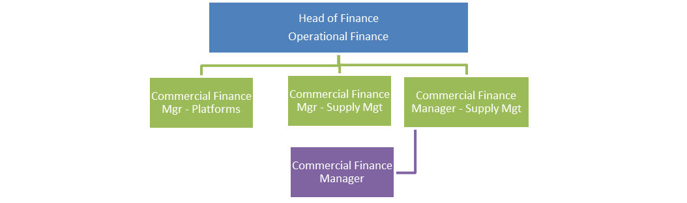

4. Context and main issues – Describe the most difficult types of problems the jobholder has to face (internal or external to Sodexo) and/or the regulations, guidelines, practices that are to be adhered to.
- Validate and make appropriate recommendations regarding the impact, accuracy and acceptance of price changes from the supply chain.
- Deliver meaningful and well understood financial analysis from high volume and complex data - allowing business decisions to be made regarding product pricing.
- Be a critical point of control to ensure data accuracy and bring clarity and transparency where supplier data takes different forms with multiple variations to units of measure.
- Analyse and be a point of approval for Supply Chain initiatives and savings. Undertake commercial valuation of savings in line with group policy.
- Engage with vendors / manufacturers to resolve purchasing income disagreements to ensure the correct value is collected by Sodexo
- Contributing to the delivery and achievement of the Regional objectives, priorities and financial targets through strong business partnering and commercial finance influence over the activities of Supply Management.
- Maintain and enhance complex financial models, including inflation analysis; product swap tracking
- Adhere to strict deadlines during quarter ends and the submission of Savings Forecast / Targets

5. Main assignments – Indicate the main activities / duties to be conducted in the job.
- Review and validate supply chain pricing and accurately manage into unit pricing.
- Validate supply chain savings and assess impact to companies gross profit.
- Manage and maintain price files for the companies approved product range within the product database.
- Deliver timely analytical insights via regular and adhoc reporting to meet the business demands.
- Lead the budgeting and forecasting process for spend and savings across Supply Management.
- Identify variation in the pricing demands of the operating business, and design and deploy appropriate pricing to meet the various business price demands on the product catalogue.
- Undertake pricing audits and establish control mechanisms which validate Supplier invoice pricing is consistent with the Product Database.
- Collate, analyse and provide actionable insights against core KPI’s to drive improved business performance and enhanced compliance.

6. Accountabilities – Give the 3 to 5 key outputs of the position vis-à-vis the organization; they should focus on end results, not duties or activities.
- Communicate accurate product price data into the product and supplier data team.
- Guide buyers and Category Managers on the commercial validity of supplier deals and make appropriate impact assessments on business performance.
- Working as key business partner to a wide range of stake holders within Regional Supply Management, Global Supply Management and the Regions Segments and CoE. Drive engagement and comprehension to ensure operational and procurement activity aligns to the regional Strategic Objectives.

7. Person Specification – Indicate the skills, knowledge and experience that the job holder should require to conduct the role effectively
Essential
- Strong analytical skills including building financial models for comparative analysis.
- Effective in Translation of financial and non-financial information to a variety of audiences, using a range of mediums, including digital tools such as Excel and PowerBI.
- Motivated and passionate and able to use initiative to work equally well alone or as part of a team and flexible in approach.
- Ability to analyse situations, draw sound judgements and take appropriate decisions.
- Shows courage to challenge actions and deliver improved outcomes.
- Training towards a recognised professional financial qualification.
- Experience of working in the commercial finance functions of global organisations.
- Exposure to a complex, contract driven business, and / or Supply Management function.
- Very strong analytical skills but with the ability to see the ‘big picture Ability to jointly apply commercial finance and control principles.
- Good team player with the ability to influence others and portray sense of direction.
- Strong evidence of resilience, energy and drive.
- Ability to work under pressure; think clearly and act decisively.

8. Competencies – Indicate which of the Sodexo core competencies and any professional competencies that the role requires
Core Competencies
Financial Rigour – Apply advanced practices and approaches for recommending, evaluating or challenging business decisions. Review the outputs of basic financial analysis and identify the need for further structured analysis to broaden and/ or deepen the level of insight being provided.
Business Relations - Analyse stakeholder interests and needs, and highlight areas to improve working relationships and/ or achieve common goals. Identify opportunities to work with a range of different business stakeholders and improve own understanding of how the business operates
Digital readiness - Understanding information, data and content in a digital environment. Helping the business to operate effectively in a digital world and responding appropriately to the constantly changing digital environment. Adopting a digital mindset in relation to all day-to-day work at Sodexo.
Courage - Stepping up to address difficult issues, saying what needs to be said, and developing and sustaining personal resilience at work
Technical Competencies
Decision Support & Management Information - Enabling the business to make sound data-led, fact-based decisions by evaluating alignment with strategy, affordability, returns and risk, whilst providing high quality management information and reporting.
Commercial Models - Developing pricing and commercial strategies and models - perform scenario planning, sensitivity analysis and/ or pricing of new products or existing product changes using defined pricing models and techniques​

9. Management Approval – To be completed by document owner
Version | Version 1.1 | Date January 2026
Document Owner | Amy Stupack

