
Job Description:
Senior Project Manager

Function: | Hard FM Technical Services
Position: | Senior Project Manager
Job holder: | TBC
Date (in job since): | TBC
Immediate manager  (N+1 Job title and name): | Daniel Amies
Additional reporting line to: | Business Director
Position location: | Hereford County Hospital
1. Purpose of the Job – State concisely the aim of the job.
You will be the lead in project management delivering a portfolio of client and Sodexo projects on site at Hereford County Hospital. Ensuring that we deliver on efficient, responsive, comprehensive, effective and high-quality projects. Supporting Sodexo’s Hard FM services to ensure we provide a safe environment suitable for the patients, visitors and Staff.

5. 2. Main assignments – Indicate the main activities / duties to be conducted in the job.
- Manage the end-to-end delivery of Sodexo and client-led projects, ensuring they are completed on time, within budget, and to the required quality standards.
- Plan, procure, and coordinate all project, planned, and reactive maintenance activities, ensuring minimal disruption to site operations and seamless service provision.
- Maintain compliance with Health & Safety legislation, site-specific rules, and Sodexo’s quality assurance and safety procedures across all works.
- Supervise and manage contractors and subcontractors, including the review of RAMS, work permits, and on-site activity, ensuring safety, quality, and compliance.
- Maintain and or improve stakeholder relationships.
- Completion of all activities to contractual timescales
- Management and compliance with HTM’s, HBN’s and relative regulations
- Communication, Responsibility, Engagement and Clear Direction

2. 3. Context and main issues – Describe the most difficult types of problems the jobholder must face (internal or external to Sodexo) and/or the regulations, guidelines, practices that are to be adhered to.
- To lead and liaise with all parties for the scope of works/specifications of proposed projects, including Lifecycle.
- To produce specifications/drawings and communicate these with contractors for tenders and costing.
- To review tenders and produce costing packages for a Trust presentation.
- To project manage projects from conception to sign off and final accounts.
- To liaise with the Trust, contractors and in-house team for access and isolations of projects.
- To have experience in budgetary control of pay and non-pay expenditure.
- To be responsible for budgets and regular budget reports.
- To be responsible to regularly update status reports on all projects for review by all parties.
- Fully aware of relevant Health and Safety and general legislative matters.
- Fully aware of Risk Assessment and Method Statements and techniques.
- A detailed appreciation of Health Technical Memorandums (HTM) and relevant Codes of Practice and Regulations across all services and disciplines.
- Fully experienced and with a strong understanding of the Construction Design Management Regulations (CDM).
- To review and authorise contractors’ documents.
- Responsibility for a service activity/ working group for ensuring compliance with all relevant Health and Safety legislation, Sodexo Zero Hard Culture, and site-specific health, safety and welfare policies.
- Must have excellent commitment, motivation, and vision.
- Excellent communications skills, both written and verbal.
- Numerate and computer literate.
- Excellent personal communication skills
- Maintain formal and informal communications with Trust Managers related to service activities/working group.

4. Accountabilities – Give the 3 to 5 key outputs of the position vis-à-vis the organization; they should focus on end results, not duties or activities.
- Performance Standards
- Building Compliance (HTM’s)
- Management of sub-contractors and specialist services and the in-house management team
- Financial Budgets
- PFI Contractual restrictions

2. 5. Dimensions – Point out the main figures / indicators to give some insight on the “volumes” managed by the position and/or the activity of the Department.
- All hard and soft facilities management services on site with a value of circa £18m
- Circa 330 Sodexo employees and numerous Trust staff supporting a 250-bed hospital

6. Job profile – Describe the qualifications (Education & experience), competencies and skills needed to succeed in the position.
Essential
- Proven experience in project management
- Mechanical, Electrical Qualification
- ONC, HNC or similar
- HTM awareness
- Excellent communication and supervisory skills, capable of leading teams and liaising with multiple stakeholders.
- Sound knowledge of the CDM Regulations
- CAD or similar programme knowledge
- Sound knowledge of Legionella prevention and management
- Sound Knowledge of Energy Management
- Sound Knowledge of Health & Safety
- Sound Building Management System Knowledge
- A customer/client facing attitude and excellent people management skills.
- Experience in managing, coaching, and influencing individuals and teams.
- Must satisfy a DBS check
- Good communication skills with the mental agility to ‘think on feet’ and provide convincing practical solutions.
- Intelligent approach of performance monitoring
- Proficient IT skills, including Excel, Word & Microsoft office

Desirable

- Experience working within a Healthcare Environment, preferably the NHS
- Preferably NEBOSH Qualified
- Previous experience within the PFI arena
- Professional Member of BIFM

2. 7. Organization chart – Indicate schematically the position of the job within the organization. It is sufficient to indicate one hierarchical level above (including possible functional boss) and, if applicable, one below the position. In the horizontal direction, the other jobs reporting to the same superior should be indicated.
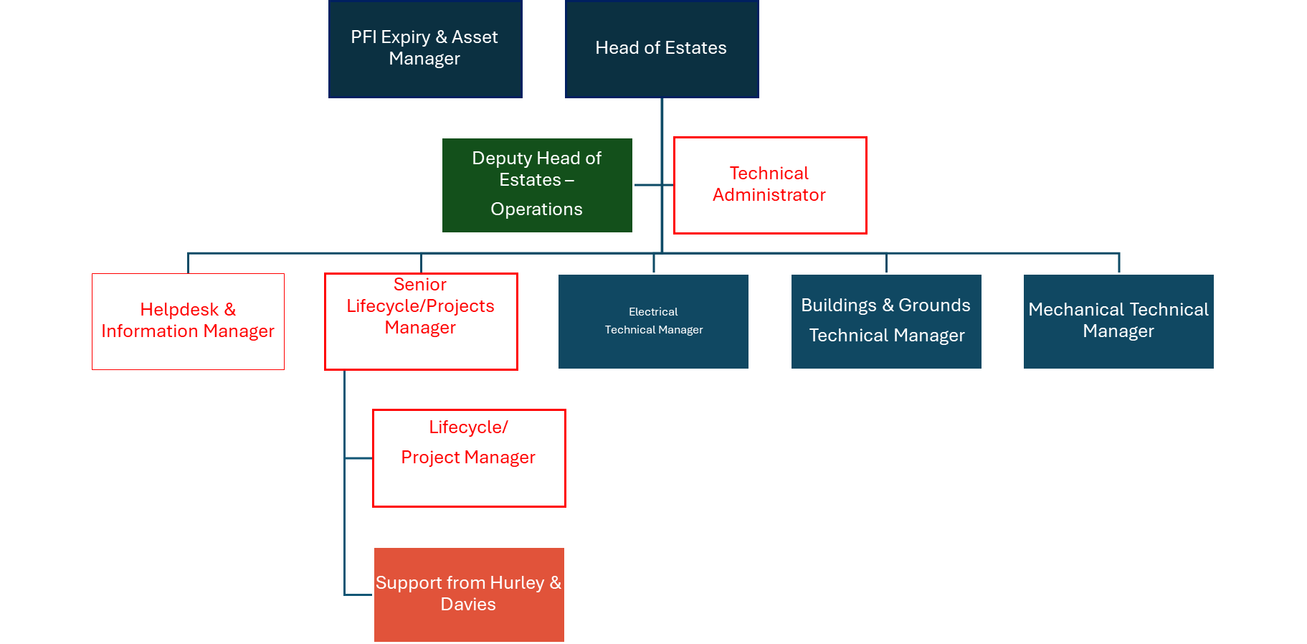

Received:

Date: Date:

__________________________________ ________________________________

Job holder Immediate Manager

